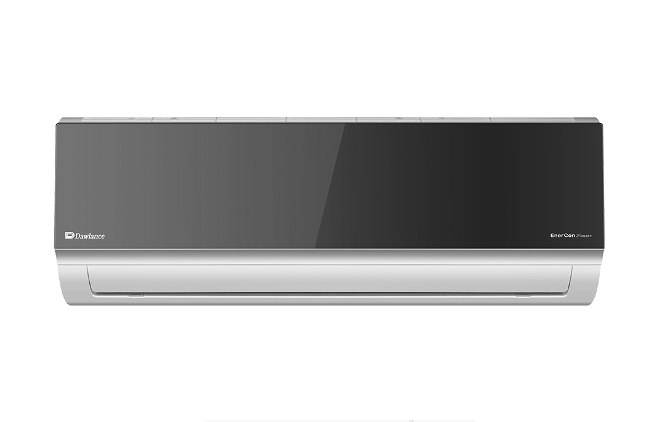

ENERCON 45

Powered with Gold Fin Anti-Rust Technology,

**Rs: 128,800.00**